Lab-report no : 02

Name of the lab report: Basic Command of Linux Operating System

Objectives:
1.What is Linux command?
2.Write 15 commands in Linux operating system.
3.Describe the operation of Linux basic command.(Screenshot)

Linux command:
Linux is a Unix-Like operating system. All the Linux/Unix commands are run in the terminal provided by the Linux system. This terminal is just like command prompt of Windows OS. Linux/Unix commands are case-sensitive.

1. hostname command: the hostname commands shows the system host name.

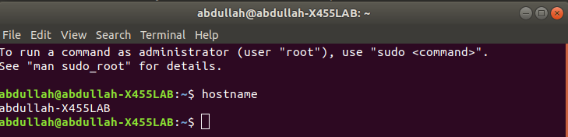

2. pwd command: It shows the directory you’re currently in.

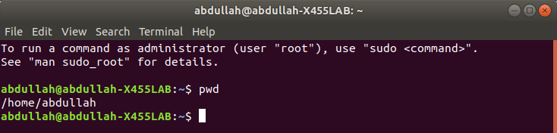

3. ls command: It shows the contents of a particular directory – both files and directories.
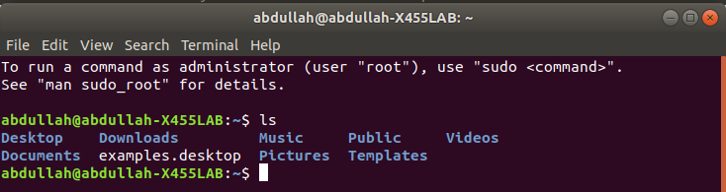

4. whoami command: It is basically the concatetion of the strings “who”,”am”,”i”.It displays the username of the current user when this command is invoked.
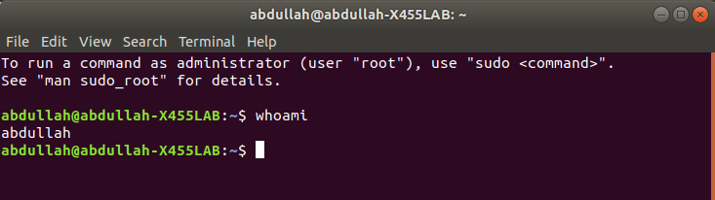

5. cal command: Displays the calendar of the current month.

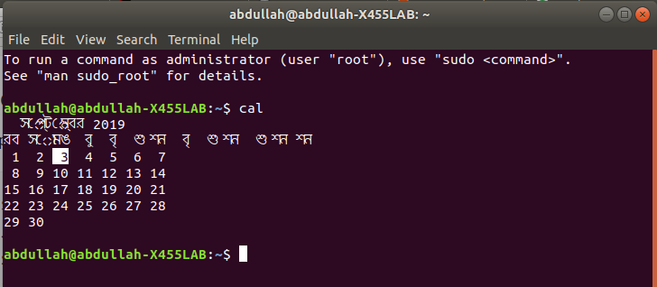

6. date command: Displays current time and date.

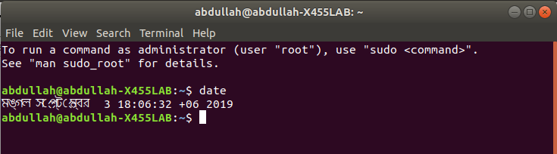

7. clear command: this command clear the screen.
Before press the enter:
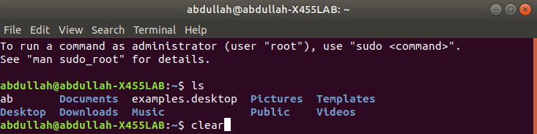
after clear command:
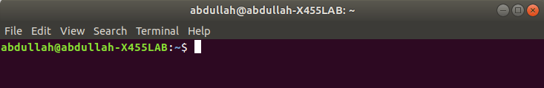

8. cd command: Change to directory . Here after changing directory I go to Documents directory.
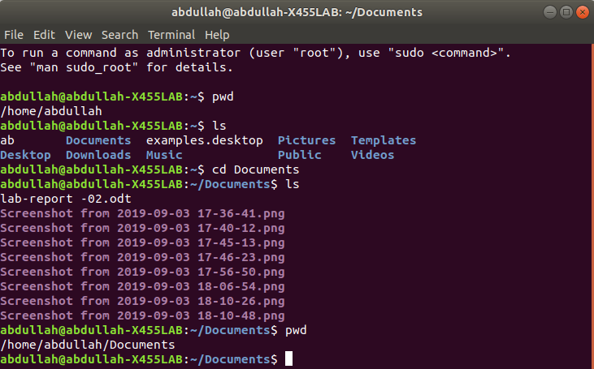

9. mkdir command : mkdir command in Linux allows the user to create directories. Here I create the khalid directory.

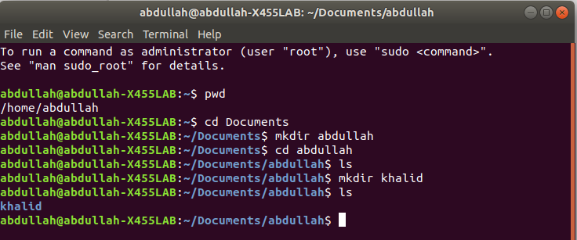
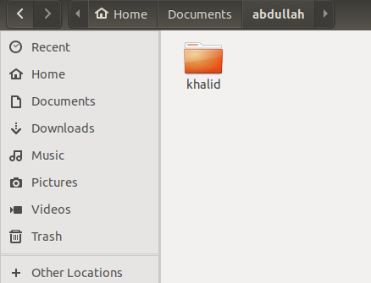

10. rmdir command: rmdir command is used remove empty directories from the filesystem in Linux. The rmdir command removes each and every directory specified in the command line only if these directories are empty . Here I first create a directory hello and then I remove that file by using rmdir.
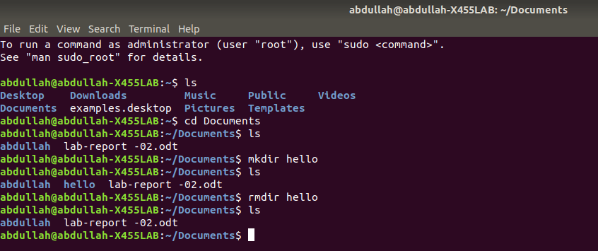

11.touch command: The touch command is used to create a file. It can be anything, from an empty txt file to an empty zip file. Here I create a new.text file using touch command.
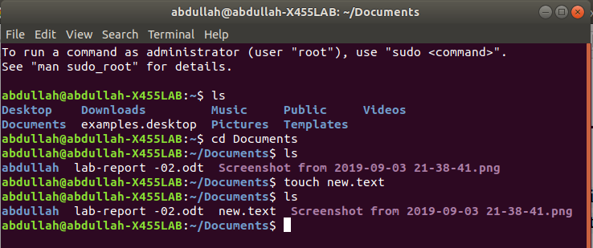

12. uname command:uname is used to show the information about the system running. Using the command “uname -a” prints most of the information about the system. This prints the kernel release date, version, processor type, etc.
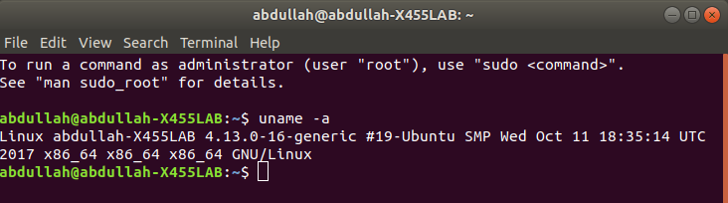

13. mv command: the mv command is used to rename a file. Here i rename the new.text file into hello.text file.
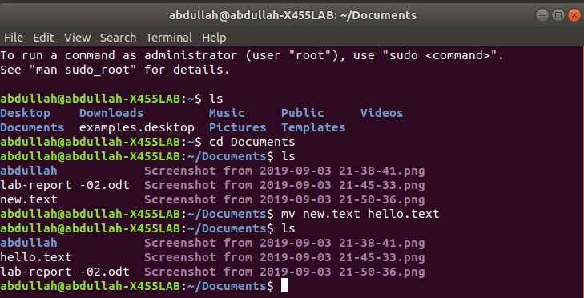

14. locate command:The locate command is used to locate a file in a Linux system, just like the search command in Windows. we can use this command when we don't know where a file is saved
or the actual name of the file.

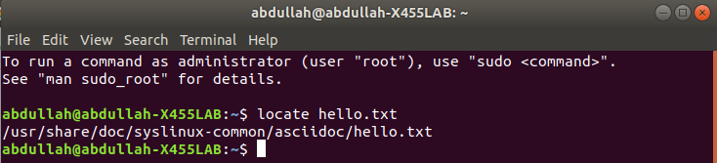

15.df command:
This command is used to check disk space usage on a linux system. The most common usage is like below, used along with the -h flag.
